MA1008 Mini Project Report Ng Chun Lin

**User Instructions**

**Start**

1. Launch the program either through IDLE or as script
2. Two choices will be offered, user input or input from a .txt file

**Data input**

1. User input will start with number of segments
2. It proceeds to input type of motion ( Dwell, Rise, Return ) , then angular range, stops here for dwell type, others continue to input curve type (Constant Acceleration, Simple Harmonic, Cycloidal), final is the displacement. Each segments parameters are collected before proceeding
3. After all the graph data has been entered, input base radius and follower radius.
4. If choosing to input from file, a list of files names will appear, enter the number corresponding to the file.
5. The data in the file will be printed for verification before proceeding
6. If data is wrong, program will return to start. If displacement at any point is less than 0, a warning will appear and ask the user whether to continue, else it returns to start.
7. After getting the data, baring any errors, the turtle screen will spawn and draw the graph and cam follower drawings.

**After viewing graph**

1. After reviewing the screen, user can choose whether to save the current data to a .txt file. If doing so, enter a name, if the name is already in use, confirmation will be asked before overwriting with new data.
2. If not saving, three options are available, enter another set of values, clears the console/shell then enter another set or end the program.
3. If doing another set, don’t close the turtle screen, it will clear and display the new set after data is entered.

**Guide to edit data file**

Sample data file (line numbers at the start of every line are not present on final data file) 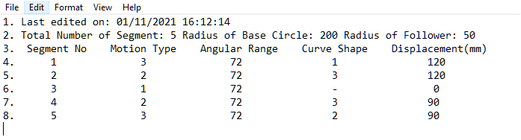

**The first line is for computer generated files will be timestamped, the content of the line is irrelevant, but the line must exist.**

**If adding or decreasing segments, need to update the total number of segment on line 2. Base circle and follower radius is up to user though as a guide max displacement should not be more than the radius.**

**Motion type choices: 1. Dwell**

**2. Rise**

**3. Return**

**Curve shape choices: 1. Constant Acceleration**

**2. Simple Harmonic**

**3. Cycloidal**

**Angular range and displacement is up to user, note all values have to be whole numbers. Total angular range needs to be 360 for file to be valid. Displacement rise and displacement return has to be equal for file to be valid.**

**Sample data files and output**

**Example 1**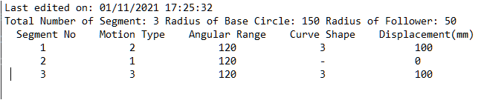

Data(Example 1)

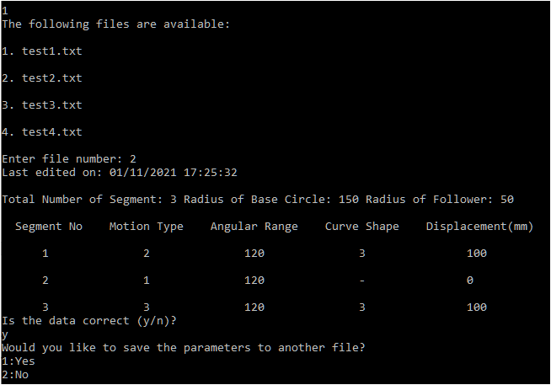

Console/Shell interaction (Example 1)

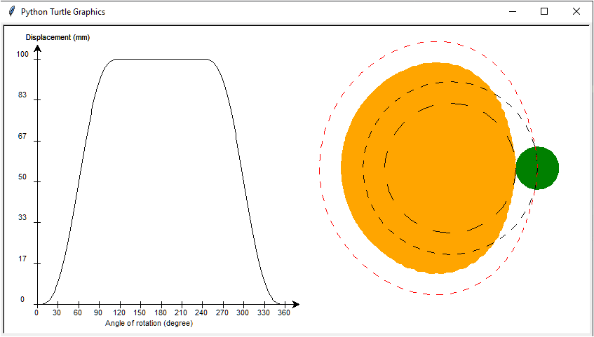Output (Example 1)

**Example 2**

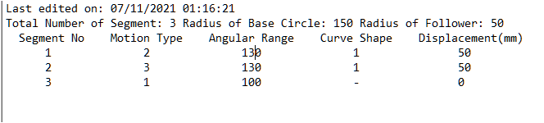

Data (Example 2)

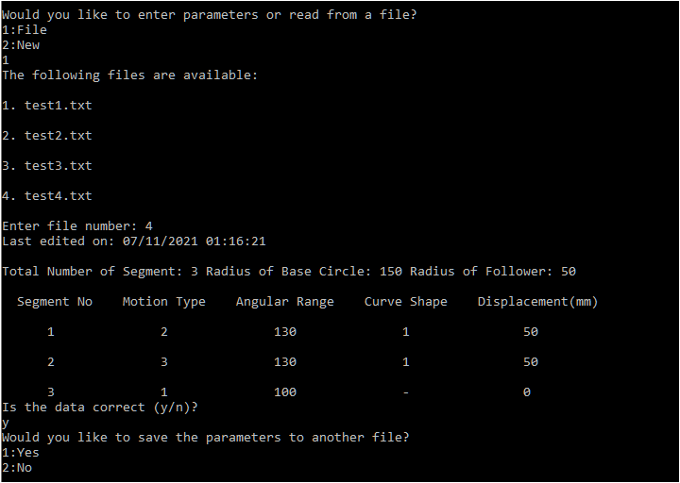

Console/Shell interaction (Example 2)

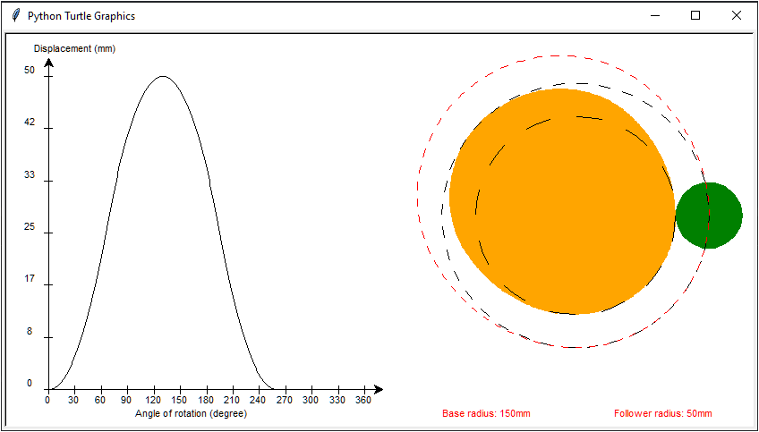

Output (Example 2)

**Program Description**

**Key Strengths**

No limit to number of segments, so long as it meets final conditions.

Can use different curve types for rise and return.

Can use any combination of motions so long as ends back at 0.

Can read from file for data.

If data has been edited wrongly or has errors, program will recognize it and raise error message.

Displays file data for user to check before proceeding.

Parameters entered can be saved to file at the end after reviewing the graph and drawing.

File can be overwritten when saving to file, will check for confirmation before proceeding.

Displays finishes drawing almost instantly.

**Limitations:**

User cannot backtrack when entering wrong values, however if values are out of range or invalid, the program will raise error messages to redo the input.

Only way to backtrack in the code only exists at a few points and returns to the start

When reading from file, only the .txt files found by the code can be read, if a file is added after entering the menu, need to reenter the menu.

Only .txt files can be used as file input.

Angular range of segments can only be int values, no float as the value is used in a for loop which cannot handle it

Displacement graph is not very smooth over long ranges

Displacement inputs can only be in mm

When dealing with negative displacements, the y axis may not show the 0 point, however the graph starts and ends at 0.